Number Sort Lab

Write a program that can sort numbers from least to greatest and greatest to least.

Example Runs:

*Least to Greatest*

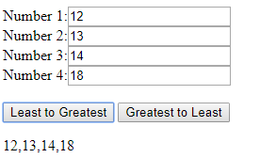

*Greatest to Least*

